Contents

1. Creating a new location code 1
2. Editing an existing location code 3
3. To remove a location from use 4

Creating a new location code

Core|Portal > People Management > Reference Data > Location Codes

Before creating a new Location Code, check the following:

- The next available Location Code number (scroll to the end of the list)
- Do any location code(s) already exist for the department in question?
- The area code for the address to be added

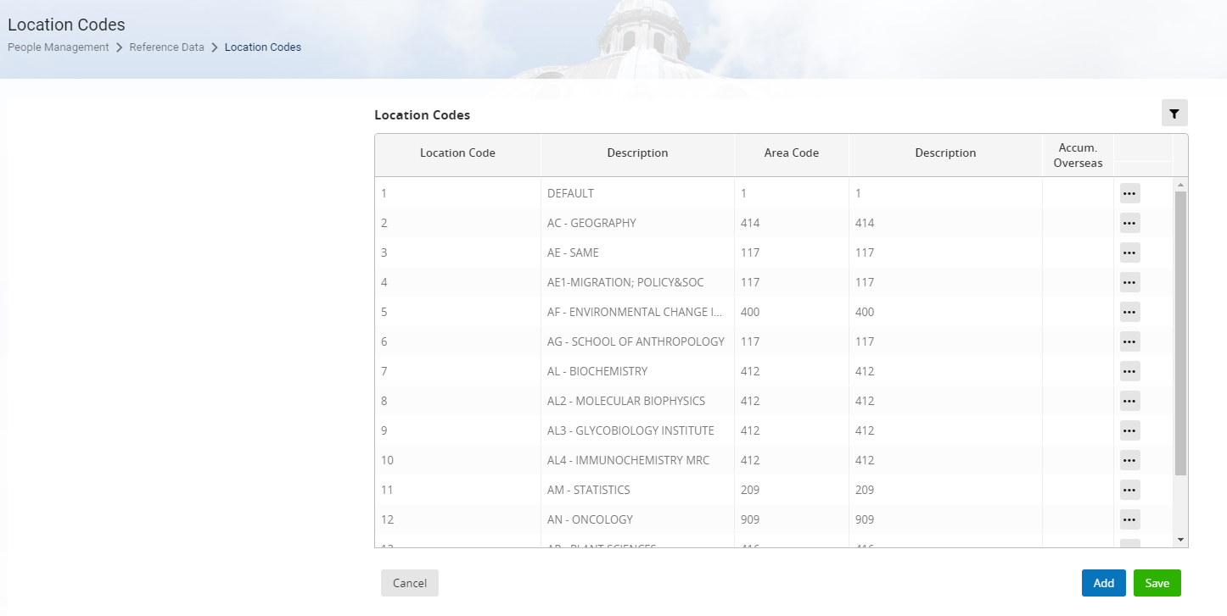

- Click on ADD to insert a new row

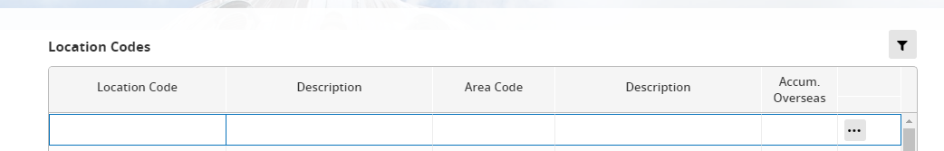

- Enter the details as follows:

Field item | Details
Location Code | Scroll down the list to find the next available number
Description | Two character dept. code followed by – followed by Location Description (often this is the department name). e.g. AA – Department  NB: If one or more location codes already exist for a department you will need to include a sequential number in the description. E.g. AA1 - Department
Area Code | Enter the area code (beat bike) number
Description | Auto populates

- Enter the new Location Code, Description and Area Code (the description will populate automatically)

 | NB: If you do not know the Area Code, look at other locations with the same address or ask Data Services to confirm the correct code

- SAVE

- Click on the ellipses (…) at the end of the new location and choose Address Details

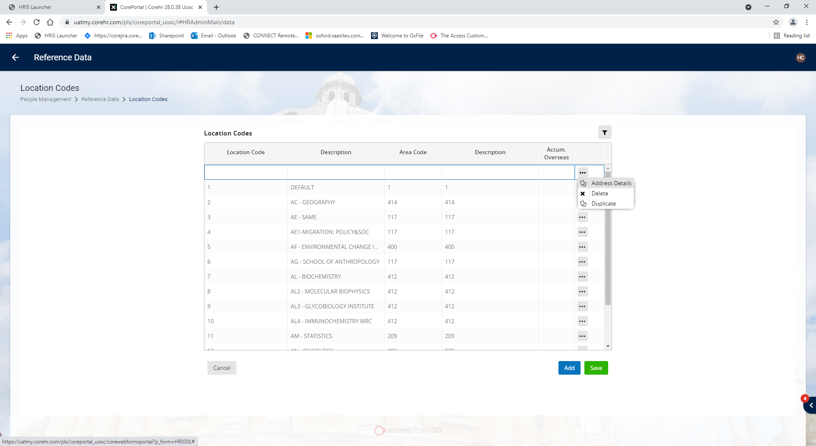

- Enter the address details.

 | NB: Address line 5 is not printed on payslips so it’s best left blank wherever possible.

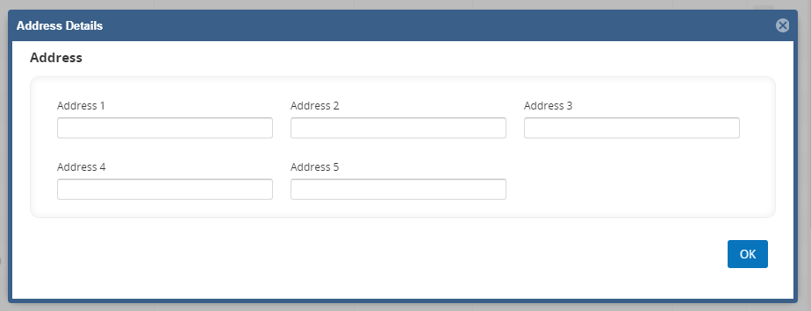
- Click OK then SAVE

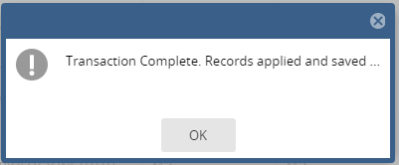

- OK the confirmation message then Cancel to exit

Editing an existing location code

Core|Portal > People Management > Reference Data > Location Codes



- Scroll down to the Location you wish to edit or use the filter option

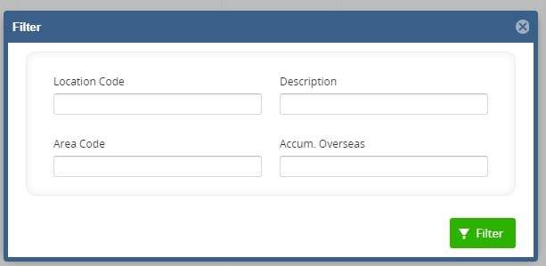
- To change the description, click into the description field and overtype the current details.



- To change the address click on the ellipses (…) at the end of the row and choose Address Details.

- Click into each field to update as required

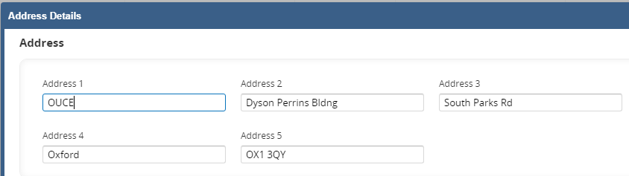

- Click OK then SAVE

- Cancel to exit

To remove a location from use

Core|Portal > People Management > Reference Data > Location Codes

We do not delete any locations as they may still be present on historic appointments.



- Scroll down to the Location you wish to edit or use the filter option



- To change the description, click into the Description field and overtype the current details. Replace the Description with DO NOT USE followed by (AA) where AA is the two character department code – see examples below:

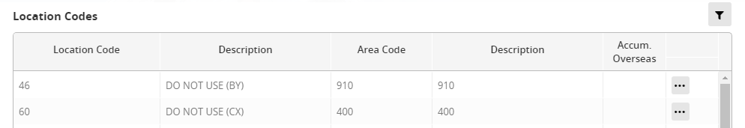

- For completeness remove the address details

- SAVE and cancel to exit

Knowledge Article: Location Knowledge Article

